

EV Population Analytics Platform on Snowflake

Technical Documentation

Freddy Alan Pérez Velazquez

1. Executive Summary 4
2. Project Overview 4
Objective 4
Dataset 4
Scope 4
3. Architecture Overview 5
Bronze Layer 5
Silver Layer 5
Gold Layer 5
Additional Layers 5
4. Data Ingestion & Source Understanding 6
Key Components 6
Approach 6
5. Data Profiling & Exploration 7
Objectives 7
Key Analyses 7
Outcome 7
6. Data Transformation (Bronze → Silver → Gold) 7
Bronze Layer 7
Silver Layer 7
Gold Layer 8
7. Data Model Design 8
Dimensions 8
Fact Table 8
Aggregations 8
Design Principles 8
Data Model Visualization 8
8. Business & Semantic Layer 10
Business Views (Gold) 10
Sharing Layer 10
Semantic Layer 10
9. Monitoring, Orchestration & Observability 10
Monitoring Tables 10
Orchestration 10
Observability 10
10. Bonus Implementations 11
1. Sharing Layer Enhancement 11
2. Automation 11
3. Data Sharing 11
4. Interoperability (Iceberg) 11
5. Openflow Integration (Design) 11
11. Limitations & Trade-offs 11
12. Future Enhancements 11
Conclusion 12

1. Executive Summary
This project demonstrates the design and implementation of a modern data platform using Snowflake, following a Medallion Architecture (Bronze, Silver, Gold). The solution processes semi-structured JSON data related to electric vehicle (EV) registrations and transforms it into analytics-ready datasets.
The implementation emphasizes:
- Data quality and governance
- Scalable transformation logic
- Business-ready data modeling
- Observability and monitoring
- Extensibility through modern Snowflake features
Additionally, several bonus features were implemented to extend the platform with minimal architectural disruption, including secure data sharing, dynamic tables, alerting, and interoperability design patterns.

2. Project Overview

Objective
The goal of this project is to build an end-to-end analytics pipeline capable of:
- Ingesting raw JSON data
- Transforming and cleaning the data
- Structuring it into a dimensional model
- Enabling business consumption and analytics

Dataset
The dataset consists of EV population data in JSON format, containing attributes such as:
- Vehicle identifiers
- Location data (state, city, county)
- Vehicle specifications (make, model, range, MSRP)
- Eligibility classifications

Scope
The solution includes:
- Data ingestion via Snowflake stages
- Transformation across Bronze, Silver, and Gold layers
- Data quality validation
- Dimensional modeling
- Business views and semantic layer
- Monitoring and orchestration
- Bonus extensions (sharing, automation, interoperability)

3. Architecture Overview
The platform follows a Medallion Architecture:

Bronze Layer
- Stores raw data as-is
- Preserves original structure for traceability

Silver Layer
- Cleans and standardizes data
- Applies validation and deduplication

Gold Layer
- Provides curated, analytics-ready datasets
- Implements dimensional modeling

Additional Layers
- SHARING: Secure data exposure
- SEMANTIC: Business-friendly datasets
- MONITORING: Observability and auditing
- OPERATIONS: Automation and alerting
- INTEROP: Future interoperability (Iceberg)
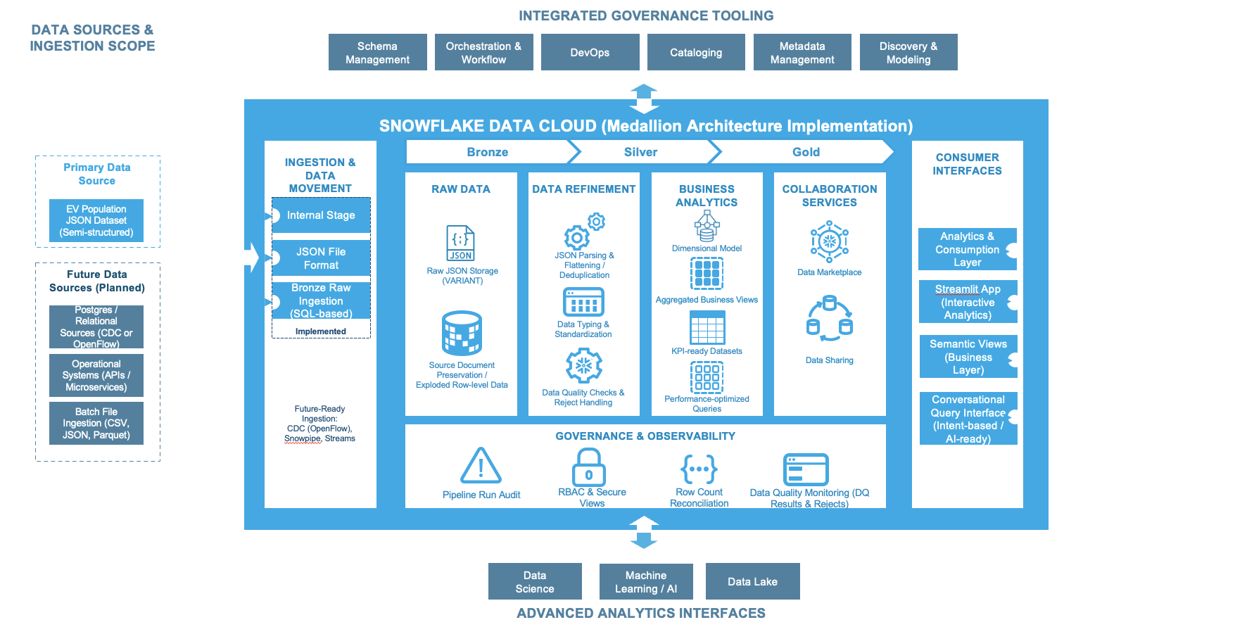

4. Data Ingestion & Source Understanding
The ingestion process begins by loading JSON data into Snowflake using an internal stage.

Key Components
- Internal Stage: EV_RAW_STAGE
- File Format: JSON
- Warehouse: EV_WH

Approach
- Load entire JSON document into a VARIANT column
- Use LATERAL FLATTEN to explode nested arrays
- Preserve metadata such as file name and ingestion timestamp
This approach ensures:
- Full traceability
- Flexibility for schema evolution
- Support for semi-structured data

5. Data Profiling & Exploration
Before transformation, exploratory data profiling was conducted to understand the dataset structure and quality.

Objectives
- Identify null values
- Detect duplicates
- Understand distributions
- Validate schema assumptions

Key Analyses
- Null checks on critical fields (make, model, state)
- Distribution of vehicle makes and model years
- Electric range statistics (min, max, average)
- Duplicate detection using vehicle identifiers

Outcome
This step was critical to:
- Define transformation rules
- Identify data quality constraints
- Design the Silver layer logic

6. Data Transformation (Bronze → Silver → Gold)

Bronze Layer
- Stores raw JSON documents and exploded rows
- Maintains ingestion metadata

Silver Layer
The Silver layer performs:
- Type casting and normalization
- String cleaning and standardization
- Business rule validation
- Deduplication using window functions
Example logic:
- Remove negative values for range and price
- Normalize text fields (uppercase, trim)
- Deduplicate using ROW_NUMBER()

Gold Layer
The Gold layer implements a dimensional model:
- Fact table: EV registrations
- Dimensions: Location, Make/Model, EV Type
- Aggregations for analytics
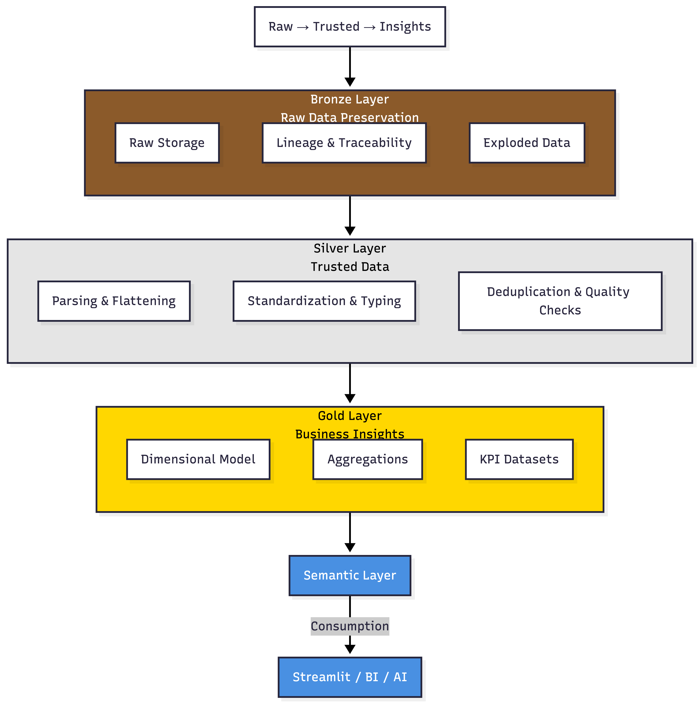

7. Data Model Design
The data model follows a star schema design.

Dimensions
- DIM_LOCATION
- DIM_MAKE_MODEL
- DIM_EV_TYPE

Fact Table
- FACT_EV_REGISTRATIONS

Aggregations
- AGG_EV_BY_STATE_YEAR
- AGG_EV_BY_MAKE
- AGG_EV_TYPE_SUMMARY

Design Principles
- Surrogate keys using hashing
- Separation of dimensions and facts
- Optimized for analytical queries

Data Model Visualization

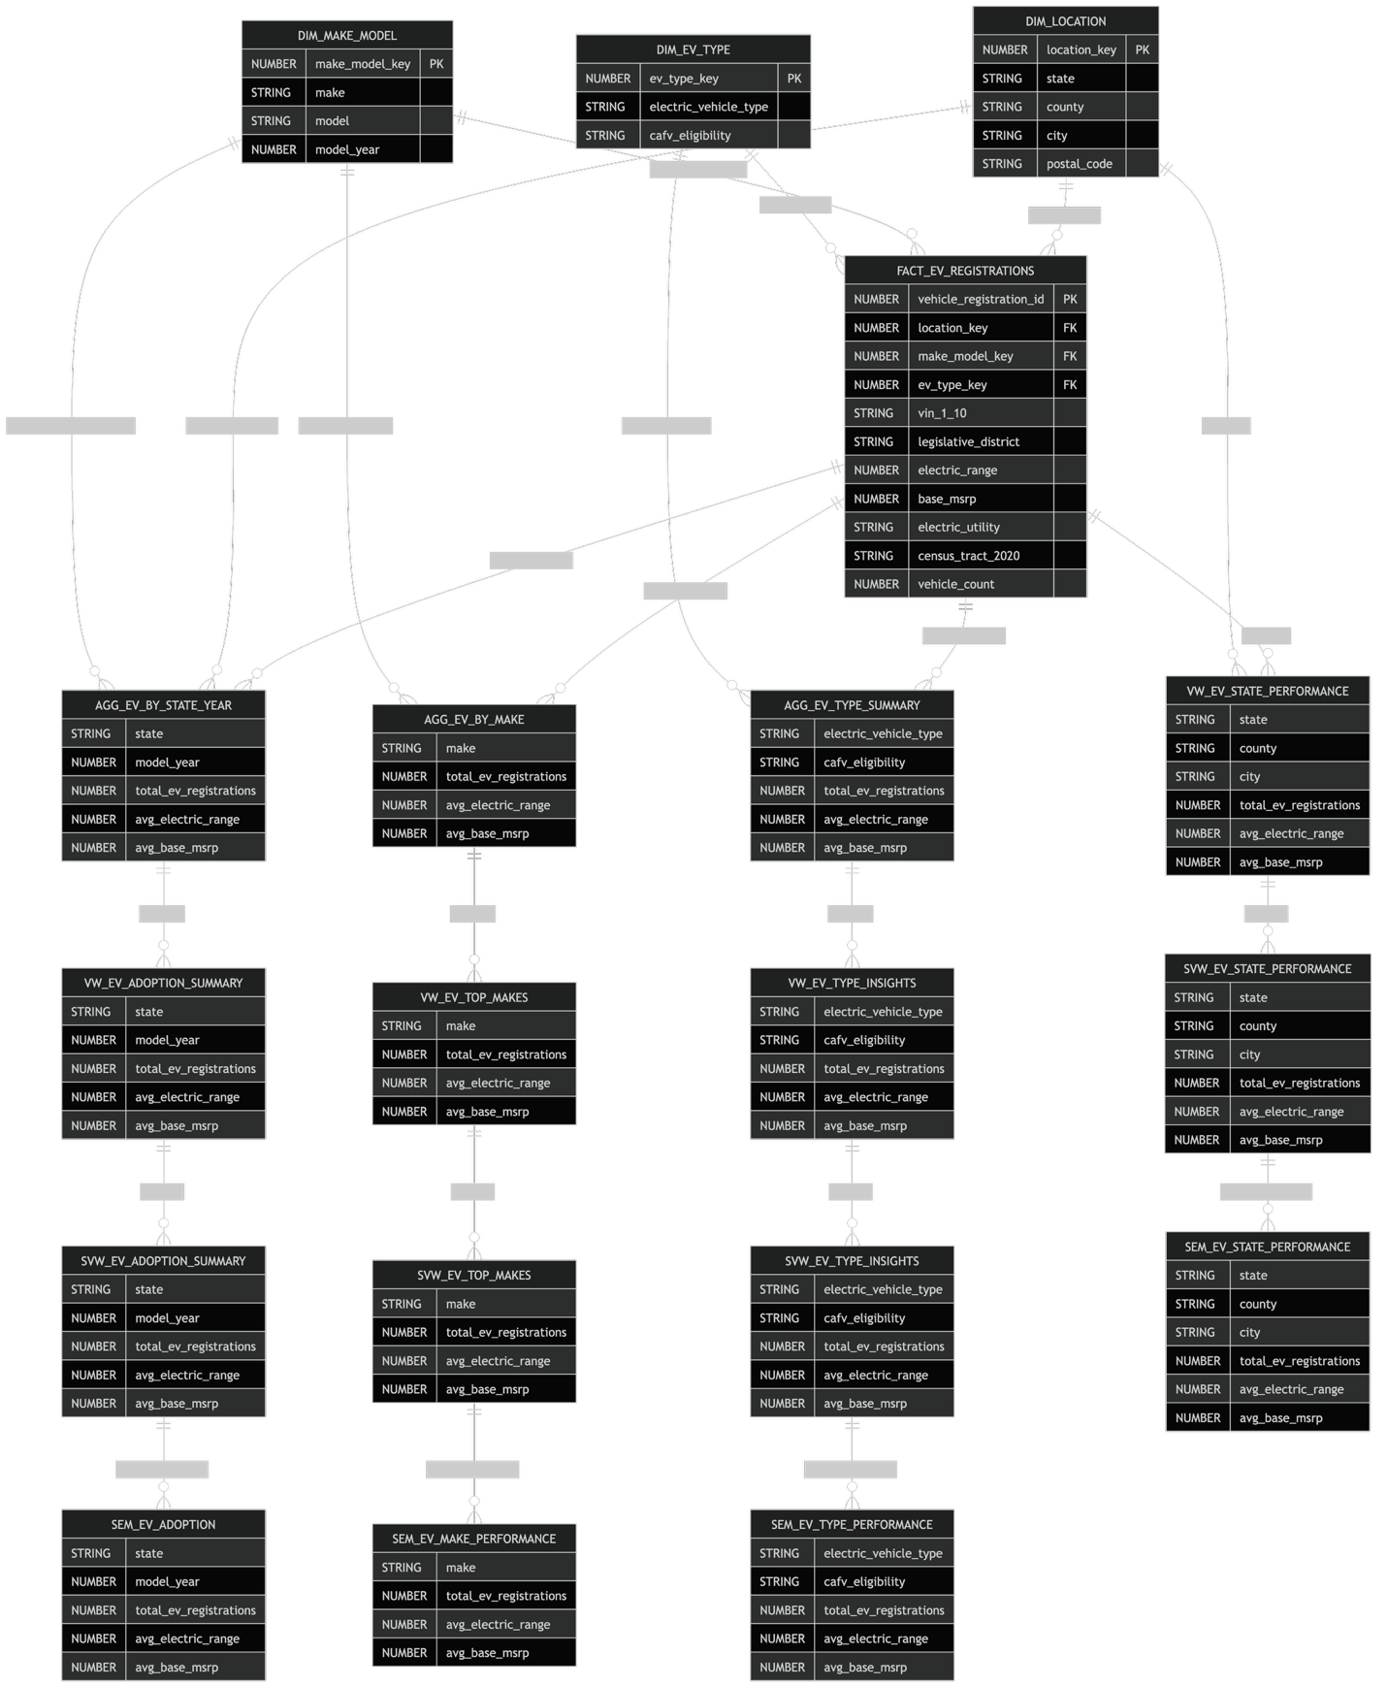
*The data model diagram is included using Mermaid ERD representation.

8. Business & Semantic Layer

Business Views (Gold)
- VW_EV_ADOPTION_SUMMARY
- VW_EV_TOP_MAKES
- VW_EV_STATE_PERFORMANCE
- VW_EV_TYPE_INSIGHTS

Sharing Layer
Secure views were created to expose curated datasets:
- SVW_EV_ADOPTION_SUMMARY
- SVW_EV_TOP_MAKES
- SVW_EV_STATE_PERFORMANCE
- SVW_EV_TYPE_INSIGHTS

Semantic Layer
Provides business-friendly naming and formatting:
- SEM_EV_ADOPTION
- SEM_EV_MAKE_PERFORMANCE
- SEM_EV_STATE_PERFORMANCE
- SEM_EV_TYPE_PERFORMANCE
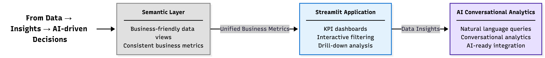

9. Monitoring, Orchestration & Observability

Monitoring Tables
- PIPELINE_RUN_AUDIT
- LAYER_ROW_COUNTS_AUDIT
- DQ_RESULTS
- TASK_HEARTBEAT_AUDIT

Orchestration
- Snowflake Tasks for scheduled execution
- Heartbeat task for monitoring

Observability
- Row count reconciliation
- Data quality validation
- Execution tracking

10. Bonus Implementations

1. Sharing Layer Enhancement
- Secure views to decouple Gold from consumers
- Enables governed data sharing

2. Automation
- Dynamic Table for incremental refresh
- Alert system for data quality failures

3. Data Sharing
- Direct Share object exposing curated datasets

4. Interoperability (Iceberg)
- Iceberg implementation provided as a template
- Not executed due to cloud configuration requirements

5. Openflow Integration (Design)
Openflow is proposed as the next-step ingestion evolution:
- Enables CDC (Change Data Capture)
- Supports integration from transactional systems
- Lands data into Bronze layer

11. Limitations & Trade-offs
- Iceberg tables were not deployed due to environment constraints
- Openflow integration was designed but not implemented
- Trial environment limits external storage configurations
These decisions were intentional to prioritize core pipeline delivery.

12. Future Enhancements
- Implement Openflow for real-time ingestion
- Deploy Iceberg tables on Azure storage
- Integrate notification services (email/webhooks)
- Add data lineage visualization
- Enhance governance and security policies

Conclusion
This project demonstrates a scalable, modular, and production-ready data platform using Snowflake. The design balances simplicity and extensibility, enabling both immediate business value and future evolution.
The implementation highlights strong practices in data engineering, including data quality, modeling, observability, and architectural design.

